Get With the Flow of Thermal Energy Unit!

Lesson Overview
Title: | Get With the Flow of Thermal Energy Unit!
Author: | Karen Bailey
Subject: | Science
Grade Level(s): | Grade 9
Duration: | 45-50 minutes
Subject Area: | Temperature (Thermal Energy)
Unit Description: | Thermal energy flows from a higher temperature to a lower temperature. Thermal energy is used to operate cars, buses, trucks, and airplanes. When using thermal energy in everyday activities, we as users must learn how to control the flow of thermal energy to keep from being too hot or too cold or from keeping appliances or objects in our home from the same. For this reason, we regulate thermal energy in a variety of ways. Scientists are able to create technologies that help regulate thermal energy. In their design, they often calculate projected changes in thermal energy.
Lesson Description for Day: | Crankin’ the temperature! Understanding Thermal Energy
State Standards:
Program of Studies
SC-H-STM-U-8
Students will understand that a system may stay the same because nothing is happening or because things are happening but exactly counterbalance one another.
SC-H-STM-S-7
Students will explore the relationships among temperature, particle number, pressure and volume in the Universal Gas Law

SC-H-STM-U-5
Students will understand that changes of state occur when enough energy is added to or removed from the atoms/molecules of a substance to change their average energy of vibration. Most solids expand as they are heated, and if sufficient energy is added the atoms/molecules lose their rigid structure and become free to move past each other as a liquid. In gases the energy of vibration is enough

Core Content
SC-HS-1.1.3
Students will understand that solids, liquids and gases differ in the distances between molecules or atoms and therefore the energy that binds them together. In solids, the structure is nearly rigid; in liquids, molecules or atoms move around each other but do not move apart; and in gases, molecules or atoms move almost independently of each other and are relatively far apart. The behavior of gases and the relationship of the variables influencing them can be described and predicted.

Goals
Unit Goals: | Define temperature.  - Explain how thermal energy depends on  temperature.  - Explain how thermal energy and heat are related.  - Calculate the change in thermal energy.  SWBAT define temperature in a written, typed, illustrated, oral, or other fashion.  SWBAT explain how thermal energy depends on temperature using student’s choice of illustration, hands-on experimentation, explanation (written, oral, typed, or audio taped) or negotiated choice.  SWBAT explain how thermal energy and heat are related using student’s choice of illustration, hands-on experimentation, explanation (written, oral, typed, or audio taped) or student/teacher negotiated choice.  SWBAT calculate the change in thermal energy using the formula Q=m(Tf-Ti)C to solve for any variable in the equation using pencil/paper, computer software, guided steps sheet, or any media necessary.
Lesson Goals: | - SWBAT define temperature and explain how thermal energy is related to thermal energy through guided note taking from a power point, participation in class demonstrations, guided practice, and through cooperative center activities.

Methods
Anticipatory Set: | BW  Distribute note-taking sheet.  Display ice cubes, glass of water, and boiling water to represent solids, liquids, and gases. Ensure each visual example includes a large print card with item names on each, and a thermometer inserted in each to increase understanding of each state of matter through auditory and visual improvements.  Ask students to recall how the particles might look in each object. Have three volunteers to stand next to each object, and use small whiteboards to illustrate how the particles are arranged. Have the rest of class complete this at the bottom or top of note taking sheet.  Have those students share their illustrations as well as the temperature reading of each object. *May use a magnifying glass for visually impaired students in order to see thermometer reading/or an audio thermometer.
Introduce and Model New Knowledge: | Explain to students that due to the motion of the particles, a temperature change can be measured.  Prompt students to take notes from the power point, as I introduce the new concepts. *Power point should include closed captioning for visually impaired students, and a headset with microphone could be on hearing impaired students so that students can adequately hear and comprehend the information to obtain a deeper understanding of the relationships between temperature and thermal energy. That student could also be positioned next to teacher.  Display the definition of thermometer. Have students read along through choral reading to reinforce the words in the definition.  Look at visual objects again. Discuss potential and kinetic energy of each object. Stress the concept of how thermal energy and mass are related.  Display thermal energy and its relationship to temperature.  Discuss and review notes taken from power point.
Provide Guided Practice: | Have student’s complete guided practice from power point so as to provide an opportunity for questions, answers, and feedback.  Discuss each example in terms of temperature and thermal energy. *Again providing closed captioning on power point.
Provide Independent Practice: | Assign Center Activities to independently practice taking temperature, and explaining how it is related to temperature.  Allow time for completion.  Review by going over responses.

Assessment
Formative/Ongoing Assessment: | Brain warmers, oral discussion, class participation, illustrations.
Summative/End Of Lesson Assessment: | Center Activities

Materials
3 beakers
Ice cubes, water, pan, stove-top or hot plate
3 thermometers
Whiteboards
Dry erase marker
Overhead projector
Mimeo board
Lesson 1 power point
Center activity handout
Guided note taking handout
Possible AT technologies available
closed captioning on Power Points
magnifying glass
visual large print cards
sound recorded power point
Online Gizmos called Phase Changes at www.explorelearning.com
Also a variety of labs available at http://www.bbc.co.uk/schools/ks2bitesize/science/materials/
Dream AT Technologies
Talking Thermometer & Cordless Headset/Microphone set

Lesson Overview 2
Title: | Get With the Flow of Thermal Energy Unit!
Author: | Karen Bailey
Subject: | Science
Grade Level(s): | Grade 9
Duration: | One to two periods of 45-50 minutes
Subject Area: | Temperature (Thermal Energy)
Unit Description: | Thermal energy flows from a higher temperature to a lower temperature. Thermal energy is used to operate cars, buses, trucks, and airplanes. When using thermal energy in everyday activities, we as users must learn how to control the flow of thermal energy to keep from being too hot or too cold or from keeping appliances or objects in our home from the same. For this reason, we regulate thermal energy in a variety of ways. Scientists are able to create technologies that help regulate thermal energy. In their design, they often calculate projected changes in thermal energy.
Lesson Description for Day: | Absorption of Radiant Energy!
State Standards:
Program of Studies
SC-H-STM-U-8
Students will understand that a system may stay the same because nothing is happening or because things are happening but exactly counterbalance one another.
SC-H-STM-S-7
Students will explore the relationships among temperature, particle number, pressure and volume in the Universal Gas Law

SC-H-STM-U-5
Students will understand that changes of state occur when enough energy is added to or removed from the atoms/molecules of a substance to change their average energy of vibration. Most solids expand as they are heated, and if sufficient energy is added the atoms/molecules lose their rigid structure and become free to move past each other as a liquid. In gases the energy of vibration is enough

Core Content
SC-HS-1.1.3
Students will understand that solids, liquids and gases differ in the distances between molecules or atoms and therefore the energy that binds them together. In solids, the structure is nearly rigid; in liquids, molecules or atoms move around each other but do not move apart; and in gases, molecules or atoms move almost independently of each other and are relatively far apart. The behavior of gases and the relationship of the variables influencing them can be described and predicted.

Goals
Unit Goals: | Define temperature.  - Explain how thermal energy depends on  temperature.  - Explain how thermal energy and heat are related.  - Calculate the change in thermal energy.  SWBAT define temperature in a written, typed, illustrated, oral, or other fashion.  SWBAT explain how thermal energy depends on temperature using student’s choice of illustration, hands-on experimentation, explanation (written, oral, typed, or audio taped) or negotiated choice.  SWBAT explain how thermal energy and heat are related using student’s choice of illustration, hands-on experimentation, explanation (written, oral, typed, or audio taped) or student/teacher negotiated choice.  SWBAT calculate the change in thermal energy using the formula Q=m(Tf-Ti)C to solve for any variable in the equation using pencil/paper, computer software, guided steps sheet, or any media necessary.
Lesson Goals: | - SWBAT define heat and tell how thermal energy and heat are related through a cooperative hands-on lab activity.

Methods
Anticipatory Set: | BW  Have students grip the metal legs of their chair for approximately 15 seconds. Then, have students place their hands on their neck and notice the change in temperature from one object to the other. Discuss observations and display the term “heat” on the mimeo board along with its meaning. Using this as a an example that should trigger prior knowledge and experiences will help students understand now how heat and thermal energy are related.  After stating objective, discuss how heat is essential for sustaining life on Earth.
Introduce and Model New Knowledge: | - Present lesson 2 power point OR http://www.brainpop.com/science/energy/heat/ discussing how certain objects or locations hold heat more easily and which ones loose heat more easily.  - Discuss the whys and how this is connected to thermal energy and an object’s specific heat. * This could also be accomplished through a power point could include closed captioning, or could be turned into a Windows Live narrated movie for students to listen to individually in the computer lab.
Provide Guided Practice: | Have students visually look at various examples, and either draw arrows to the object that is losing its heat more quickly or circle the object that holds heat the best. *This could be done on the computer, with the Paint program, or discussed aloud to increase kinesthetic experiences that may be needed for comprehension.
Provide Independent Practice: | Assign Absorption of Radiant energy Lab.  Allow time for completion.  Review by going over responses and recapping objectives.

Assessment
Formative/Ongoing Assessment: | Brain warmers, oral discussion, class participation, illustrations
Summative/End Of Lesson Assessment: | Absorption of Radiant Energy Lab

Materials
Overhead projector
Mimeo board
Lesson 2 power point
Absorption of Radiant Energy
5 graduated cylinders- 1 for each group
5 heat lamps- 1 for each group
20 paper cups with lips- 4 for each group
20 thermometers- 4 for each group
4 colors of tempera paint- red, black, white, yellow
Watch or clock
Water
Apron
Sponges or brushes- 1 for each person- this could even be cotton
Possible AT technologies available
closed captioning on Power Points
magnifying class
visual large print cards
sound recorded power point
Online Lab Gizmos Heat Transfer by Conduction and Heat Absorption
at http://www.explorelearning.com
Dream AT Technologies
Cordless Headset/microphone set

Lesson Overview 3
Title: | Get With the Flow of Thermal Energy Unit!
Author: | Karen Bailey
Subject: | Science
Grade Level(s): | Grade 9
Duration: | One to two periods of 45-50 minutes
Subject Area: | Temperature (Thermal Energy)
Unit Description: | Thermal energy flows from a higher temperature to a lower temperature. Thermal energy is used to operate cars, buses, trucks, and airplanes. When using thermal energy in everyday activities, we as users must learn how to control the flow of thermal energy to keep from being too hot or too cold or from keeping appliances or objects in our home from the same. For this reason, we regulate thermal energy in a variety of ways. Scientists are able to create technologies that help regulate thermal energy. In their design, they often calculate projected changes in thermal energy.
Lesson Description for Day: | Calculating a Change in Thermal Energy!
State Standards:
Program of Studies
SC-H-STM-U-8
Students will understand that a system may stay the same because nothing is happening or because things are happening but exactly counterbalance one another.
SC-H-STM-S-7
Students will explore the relationships among temperature, particle number, pressure and volume in the Universal Gas Law

SC-H-STM-U-5
Students will understand that changes of state occur when enough energy is added to or removed from the atoms/molecules of a substance to change their average energy of vibration. Most solids expand as they are heated, and if sufficient energy is added the atoms/molecules lose their rigid structure and become free to move past each other as a liquid. In gases the energy of vibration is enough

Core Content
SC-HS-1.1.3
Students will understand that solids, liquids and gases differ in the distances between molecules or atoms and therefore the energy that binds them together. In solids, the structure is nearly rigid; in liquids, molecules or atoms move around each other but do not move apart; and in gases, molecules or atoms move almost independently of each other and are relatively far apart. The behavior of gases and the relationship of the variables influencing them can be described and predicted.

Goals
Unit Goals: | Define temperature.  - Explain how thermal energy depends on  temperature.  - Explain how thermal energy and heat are related.  - Calculate the change in thermal energy.  SWBAT define temperature in a written, typed, illustrated, oral, or other fashion.  SWBAT explain how thermal energy depends on temperature using student’s choice of illustration, hands-on experimentation, explanation (written, oral, typed, or audio taped) or negotiated choice.  SWBAT explain how thermal energy and heat are related using student’s choice of illustration, hands-on experimentation, explanation (written, oral, typed, or audio taped) or student/teacher negotiated choice.  SWBAT calculate the change in thermal energy using the formula Q=m(Tf-Ti)C to solve for any variable in the equation using pencil/paper, computer software, guided steps sheet, or any media necessary.
Lesson Goals: | - SWBAT calculate the change in thermal energy through viewing a Windows Live Movie, guided practice, and independent practice.

Methods
Anticipatory Set: | BW- Watch PowerPoint Narration, “Real Life Need for Calculating Thermal Energy” to help students both see and hear how being able to solve for thermal energy is closely related to real life products and experiences very personal to them.
Introduce and Model New Knowledge: | - Distribute Heat Transfer Guided Practice.  - Have students visually observe how to complete one problem. This can be accomplished by instructor physically modeling a problem, or if students prefer, they may watch and listen to the problem performed on the power point so that they may review, and hear each part clearly for a more complete understanding of the processes involved.  - Have students follow 3-5 board examples and work with teacher guidance.
Provide Guided Practice: | Have student’s complete 5-10 practice problems.
Provide Independent Practice: | Assign remaining problems to be completed independently.

Assessment
Formative/Ongoing Assessment: | Brain warmers, guided practice
Summative/End Of Lesson Assessment: | Independent Practice Page Heat Transfer Problems

Materials
Overhead projector
Mimeo board
Windows Live Movie
Calculators
Handouts of Heat Transfer Problems

Possible AT technologies available
closed captioning video
online talking calculator at http://pbskids.org/cyberchase/games/calculator/index.html Online tutorial http://www.fordhamprep.org/gcurran/sho/sho/lessons/lesson210.htm
How to solve problems http://www.youtube.com/watch?v=dA3ePiwSyGY
http://www.youtube.com/watch?v=XwCLvJdVrIs
Dream AT Technologies
Comfort Duett Sound Amplifier

Crankin’ the Temperature! Understanding Thermal Energy

Activity 1
- Fill a test tube or obtain a filled test tube with 20 mL of water. Use thermometer to record temperature here ___________.
- Rub hands together to create heat. Continue this action for approximately 1 minute without stopping.
- Carefully grip the test tube & measure the temperature of the test tube again. Record here __________.
  - Draw the particles of the water as you would imagine them to appear before and after. BEFORE AFTER

- What is the change in the measure of the average kinetic energy in the test tube? ________

Activity 2
- Obtain a sample of coffee. Take the temperature of the sample. Record here ______.
- Drop 2 ice cubes into the sample of coffee. Wait 1 minute. Record temperature of coffee sample now. Record here _________.
- Draw a before and after picture of the molecules in the coffee.
  - BEFORE AFTER

Temperature vs. Thermal energy Demonstrations

Temperature
Can shaking increase the temperature of sand?
Procedure:
- Pour sand into a plastic cup (with a well fitting lid) until the sand is deep enough to cover the bulb of a thermometer.
- Measure the temperature of the sand to the nearest tenth of a degree. Remove the thermometer.
- Place the lid snugly on the cup. While holding the lid firmly in place, shake the cup vigorously for several minutes.
- Stop shaking, remove the lid, and immediately use the thermometer to measure the temperature of the sand.
Analysis:
- What effect did shaking have on the temperature of the sand?
- Was energy created? Explain why or why not?

Thermal energy
Start with 2 beakers of room temperature water and one beaker of boiling water.
Put 10 washers on a string and 30 on a second string.
Lower the strings into the water for a few minutes.
Take the temp of the water in the two room temp beakers.
Take the temperature of the heated water containing the washers.
Lower the washers into the room temperature beakers and take the temp again after a couple of minutes
Compare the temp of the 2 beakers. Why are they different?

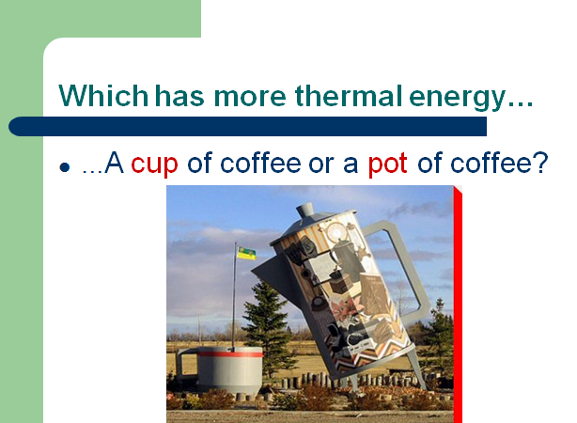
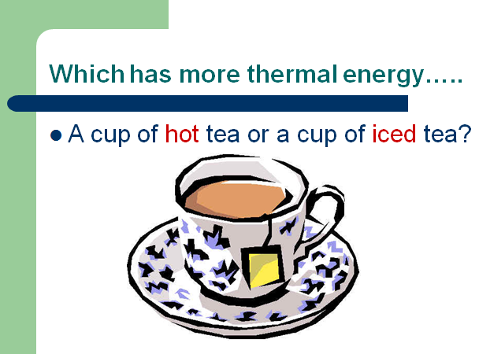
Lesson 2

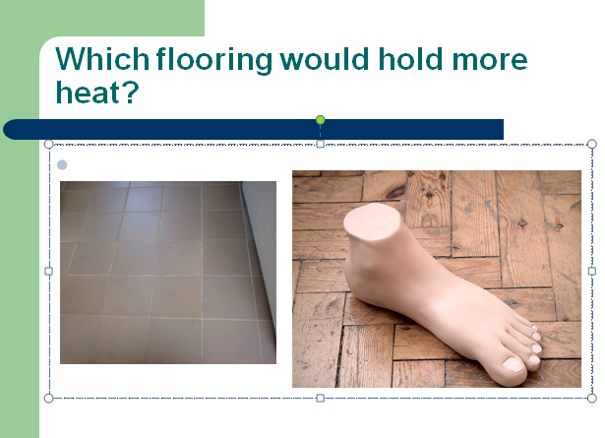
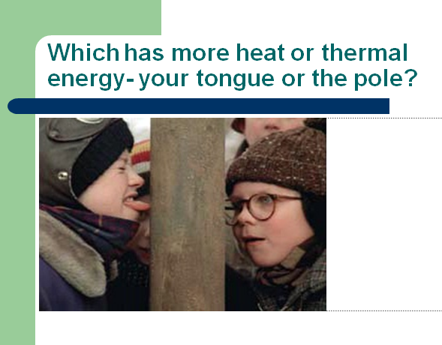

Heat Transfer Calculations
q = m(ΔT)Cp
Use the above formula to solve the problems below. Remember to list the known and unknowns.
Guided Practice
- Find the mass of a piece of copper when 8000.0 J of heat are applied, causing a 45 ºC increase in temperature. (Cp of copper is 0.38452 J/g x C)

- Find the specific heat of an unknown metal with an initial temperature of 16.0 ºC, when 3500 Joules are applied to a 40.0g sample and the final temperature is 81.0 ºC.

- How much heat is transferred when a 25.25 g piece of copper is heated from 10 degrees C to 18 degrees C? Look of the Cp of copper in the back of your textbook.

- How much heat is transferred when 50.0 g of water is heated from 8 degrees C to 24 degrees C? The Cp of water is 1.00 cal/g x ºC.

- How much heat is transferred when a 65.0g of water is heated from 7.5 degrees C to 30.5 degrees C? The Cp of water is cal/g x ºC.

Independent Practice
1. How many calories of heat are required to raise the temperature of 550 g of water from 12.0 ºC to 18.0 ºC? (remember the specific heat of water is 1.00 cal/g x ºC)

2. How much heat is lost when a 640 g piece of copper cools from 375 ºC, to 26 ºC? (The specific heat of copper is 0.38452 J/g x ºC)

3. The specific heat of iron is 0.4494 J/g x ºC. How much heat is transferred when a 24.7 kg iron ingot is cooled from 880 ºC to 13 ºC?

Answers 1) 3300 cal 2) 86 000 J 3) 9 600 000 J

1. How many degrees would the temperature of a 450 g ingot of iron increase if 7600 J of energy are applied to it? (The specific heat of iron is0.4494 J/g x ºC)

2. A 250 g sample of water with an initial temperature of 98.8 ºC loses 7500 joules of heat. What is the final temperature of the water? (Remember, final temp = initial temp - change in temp)

3. Copper has a specific heat of 0.38452 J/g x ºC. How much change in temperature would the addition of 35 000 Joules of heat have on a 538.0 gram sample of copper?

Answers 1) 38 ºC 2) 92 ºC 3) 170 ºC

1. Determine the specific heat of a certain metal if a 450 gram sample of it loses 34 500 Joules of heat as its temperature drops by 97 ºC.

2. 4786 Joules of heat are transferred to a 89.0 gram sample of an unknown material, with an initial temperature of 23.0 ºC. What is the specific heat of the material if the final temperature is 89.5 ºC?

3. The temperature of a 55 gram sample of a certain metal drops by 113 ºC as it loses 3500 Joules of heat. What is the specific heat of the metal?

Answers 1) 0.79 J/g x ºC 2) 0.809 J/g x ºC 3) 0.56 J/g x ºC

Self- Assessment Tools 1-3
Self-Assessment Tool 1

- The easiest part of today’s activity was… ____________________________________________________________________________________________________________________________________________________________

- The hardest part of today’s activity was…
_____________________________________________________________________________________________________________________________________________________________________

- Today’s activity helped me …
_____________________________________________________________________________________________________________________________________________________________________

- The part of the activity I enjoyed the most was …
_____________________________________________________________________________________________________________________________________________________________________

- The part of the activity I liked least was …
_____________________________________________________________________________________________________________________________________________________________________

Self Assessment Tool 2

- Draw the easiest part of today’s activity

- Draw the hardest part of today’s activity

- Draw how today’s activity helped you

- Draw the part of the activity you enjoyed most

- Draw the part of the activity you liked least

Self Assessment Tool 3
Directions-
- Go to the computer. Click the Start Menu.
- Open My Podcast Recorder.
- Read the sentences below, and finish them with your own responses to assess today’s activities.
  - For example, The easiest part of today’s activity was the hands-on lab, because it helped me understand that particles in solids do not move as quickly as particles in gas.
- When finished, click the record button again to stop the recording.
- Press save, and include the title, “mynameselfassessment.” Click save

---------------------------------------------------------------------------------------------

- The easiest part of today’s activity was…
- The hardest part of today’s activity was…
- Today’s activity helped me …
- The part of the activity I enjoyed the most was …
- The part of the activity I liked least was …

Crankin’ the Temperature! Understanding Thermal Energy
Lesson 1 Alternative Activites

- After completing the online gizmo lab entitled, “Phase Changes” define “temperature” by either writing the definition below, typing it below, illustrating it below, explaining it audibly on the My Podcast Recorder, etc.

- Go to http://www.bbc.co.uk/schools/ks2bitesize/science/materials/ Click on, “Gases, Liquids, and Solids and complete online activity by playing, reading, and taking quiz.

Name: ______________________________________ Date: ________________________

Student Exploration: Phase Changes
Go to http://www.explorelearning.com/index.cfm?method=cResource.dspDetail&ResourceID=557

Vocabulary: altitude, boil, boiling point, freeze, freezing point, gas, liquid, melt, melting point, phase, solid

Prior Knowledge Questions (Do these BEFORE using the Gizmo.)

- A family from Minnesota turns off the heat and flies to Florida for a winter holiday. When they come home, all of their water pipes have burst. What do you think happened?

_________________________________________________________________________

- Spaghetti takes about 9 minutes to cook at sea level, but about 14 minutes in the mountains. Why do you think this is so?

_________________________________________________________________________

_________________________________________________________________________

Gizmo Warm-up
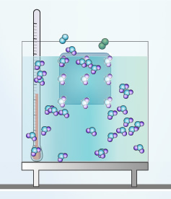
In the Phase Changes Gizmo™, select the Micro view and set the Ice volume to 50 cc. Click Play () and observe molecules in the solid (ice), liquid (water), and gas (air) phases.

- In which phase(s) are the molecules held rigidly together?

______________________________________________

- In which phase(s) do the molecules move freely?

______________________________________________

- In which phase(s) are the molecules held in a defined shape? ________________________

- In which phase(s) do the molecules take the shape of their container? _________________

_________________________________________________________________________
Activity A:  Phase changes | Get the Gizmo ready:  - Click Reset () and select Macro view.  - Set Ice volume to 0 cc. | 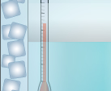

Question: How is temperature related to phase changes?

- Predict: Based on your prior knowledge, predict the following:

    - At what temperature will water change from a liquid to a solid (freeze)? _______

    - At what temperature will water change from a solid to a liquid (melt)? _______

    - At what temperature will water change from a liquid to a gas (boil)? _______

- Investigate: Use the Gizmo to explore phase changes. Use the Water temperature and Add/remove heat energy sliders to control the water temperature. Record your observations in your notes, then answer the questions below:

    - At what temperature does water freeze? _______ This is the freezing point.

    - At what temperature does ice melt? _______ This is the melting point.

    - At what temperature does water boil? _______ This is the boiling point.

- Observe: Set up the Gizmo to observe freezing. What do you notice about the temperature while the water is in the process of freezing? _____________________________________

- Explore: Use the Gizmo to investigate melting and boiling. Does the temperature change as either of these phase changes is occurring? ______________________________________

- Interpret: Select the GRAPH tab to see a graph of temperature vs. time. Click the “–” button until the whole graph is visible. What does the graph look like during a phase change?

_________________________________________________________________________

- Extend your thinking: Why do you think the temperature does not change much during a phase change? If possible, discuss your answer with your classmates and teacher.

_________________________________________________________________________

_________________________________________________________________________

Activity B:  Temperature and molecular motion | Get the Gizmo ready:  - Click Reset, and select the Micro view.  - Set Ice volume to 0 cc.  - Set Add/remove heat energy to 0 J/s. | 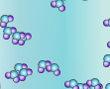

Question: Why do phase changes occur?

- Observe: Set the Water temperature to 0 °C and click Play. Observe the water molecules. Click Reset, set the Water temperature to 100 °C, and click Play again. What do you see?

_________________________________________________________________________

- Explain: How is temperature related to the motion of molecules? ______________________

_________________________________________________________________________

- Observe: Click Reset. Set the Water temperature to 20 °C and the Ice volume to 50 cc. Click Play. How do the molecules in the liquid interact with the molecules in the solid?

_________________________________________________________________________

- Observe: Click Reset. Set the Water temperature to 100 °C and the Ice volume to 50 cc. Click Play. How does this situation compare to the previous one?

_________________________________________________________________________

_________________________________________________________________________

- Propose a theory: Based on what you have observed, explain why you think phase changes occur. If possible, discuss your theory with your classmates and teacher.

_________________________________________________________________________

_________________________________________________________________________

_________________________________________________________________________

- Extend your thinking: Click Reset. Set the Water temperature to 0 °C, the Ice volume to 0 cc, and Add/remove heat energy to -400 J/s. Click Play and wait until all the water freezes.

    - What volume of ice is created from 200 cc of water? _________________________

    - Why do water pipes sometimes burst in the winter? __________________________

___________________________________________________________________

Extension:  Altitude and phase changes | Get the Gizmo ready:  - Click Reset.  - Set Ice volume to 0 cc.  - Set the Altitude to 5,000 meters (16,404 feet). | 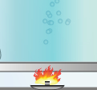

Question: The altitude of a location is its vertical distance above sea level. How does altitude affect phase changes?

- Form a hypothesis: As altitude increases, the air pressure decreases. How do you think the lower pressure will affect the following? (Circle your answers.)

    - Freezing point: Increase Stay the same Decrease

    - Melting point: Increase Stay the same Decrease

    - Boiling point: Increase Stay the same Decrease

- Experiment: Use the Gizmo to find the freezing, melting, and boiling points of water at 5,000 meters (16,404 feet). Write these values below.

Freezing point: _______ Melting point: _______ Boiling point: _______

- Analyze: How did altitude affect the freezing, melting, and boiling points of water?

_________________________________________________________________________

_________________________________________________________________________

- Challenge: Try to explain these results based on the fact that air pressure decreases with altitude. If possible, discuss your ideas with your classmates and teacher.

_________________________________________________________________________

_________________________________________________________________________

- Apply: Why does pasta take longer to cook in the mountains? ________________________

_________________________________________________________________________

- Apply: A pressure cooker allows food to be cooked under high pressure. Why is this useful?

_________________________________________________________________________

_________________________________________________________________________
Lesson 2 Alternatives
Go to http://www.explorelearning.com/index.cfm?method=cResource.dspDetail&ResourceID=388

Name: ______________________________________ Date: ________________________

Student Exploration: Heat Transfer by Conduction

Vocabulary: conduction, convection, insulate, radiation, thermal conductor, thermal energy, thermal insulator

Prior Knowledge Questions (Do these BEFORE using the Gizmo.)
Suppose two frying pans have been left on the stove with the burners on. One of the frying pans has a metal handle and the other has a wooden handle.

- Which handle do you think you could safely touch? ________________________________

- Why do you think one handle will be cooler than the other? __________________________

_________________________________________________________________________

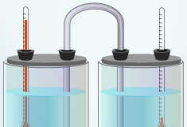
Gizmo Warm-up
Heat, also called thermal energy, can be transmitted through space (radiation), by moving fluids (convection), or through direct contact. This final method, called conduction, is explored in the Heat Transfer by Conduction Gizmo™.

To begin, check that Aluminum is selected. Select the BAR CHART tab and turn on Show numerical values.

- What is the initial temperature of each beaker? Beaker A _________ Beaker B _________

- Click Play () and observe.

  - What happens to the temperature of Beaker A over time? _____________________

___________________________________________________________________

  - What happens to the temperature of Beaker B over time? ____________________

___________________________________________________________________

- Why do you think the temperatures of Beaker A and Beaker B changed as they did?

_________________________________________________________________________

_________________________________________________________________________

Activity A:  Measuring heat transfer | Get the Gizmo ready:  - Click Reset ().  - Check that Aluminum is selected. | 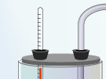

Question: How does the temperature difference between two containers relate to the rate of temperature change?
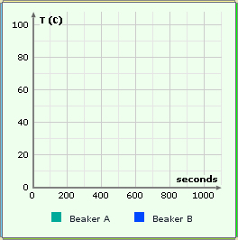
- Observe: Select the GRAPH tab and press Play. Wait until the temperatures of the two beakers are both close to 50 °C, and use the zoom out button () to see the whole graph. Sketch the graph in the space at right.

What does the graph show about the rate of temperature change over time?

_________________________________________

_________________________________________

_________________________________________

- Form hypothesis: How do you think the temperature difference between the beakers relates to the rate of heat transfer? ___________________________________________________
_________________________________________________________________________

- Gather data: Select the TABLE tab. Click Reset, and then click Play. Click Pause () every 100 seconds (does not have to be exact). Each time you click Pause, record the temperature of each beaker and their temperature difference in the table below. (To find the temperature difference, subtract the temperature of beaker B from that of beaker A.)

Time (s) | Beaker A temp. (°C) | Beaker B temp. (°C) | Temp. difference (°C)
0 s
100 s
200 s
300 s
400 s
500 s
600 s

- Calculate: At each time, what is the sum of the temperatures in each beaker? ___________

- Apply: In this simulation, the beakers are perfectly insulated. This means that no thermal energy (heat) is lost to the outside environment. If the beakers were not perfectly insulated, how do you think the sum of their temperatures would change over time? Explain.

_________________________________________________________________________

_________________________________________________________________________

_________________________________________________________________________

- Compare: Compare the temperature changes in the 0–100 second interval to the 500–600 second interval. First, record the temperature difference at the start of each interval. Then, calculate how much the temperature in each beaker changed during the interval.

Value | 0–100 s interval | 500–600 s interval
Temperature difference at the start of the time interval
Change in Beaker A temperature
Change in Beaker B temperature

- Analyze: How does the rate of temperature change depend on the temperature difference between the two beakers? ____________________________________________________
_________________________________________________________________________

_________________________________________________________________________

- Think and discuss: Why do you think the rate of temperature change does not stay constant over time? If possible, discuss your answer with your teacher and classmates.

_________________________________________________________________________

_________________________________________________________________________

_________________________________________________________________________

Activity B:  Conductors and insulators | Get the Gizmo ready:  - Click Reset ().  - Select the TABLE tab. | 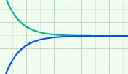

Introduction: Materials that allow heat to pass through easily are called thermal conductors. Materials that resist the transfer of heat are called thermal insulators.

Question: Which materials are the best conductors? Which are the worst conductors?

- Predict: In the Gizmo, you can use aluminum, copper, steel, or glass to connect the two insulated beakers.

    - Which material do you think will be the best thermal conductor? ________________

    - Which material do you think will be the best thermal insulator? ________________

- Gather data: With Aluminum selected, click Play. Click Pause after about 200 simulated seconds. Record the temperature of each beaker at 200 seconds. Next, calculate the temperature change of Beaker A. Repeat with each material to complete the table.

Material | Beaker A temp. at  200 seconds (°C) | Beaker B temp. at  200 seconds (°C) | Beaker A temp. change (°C)
Aluminum
Copper
Steel
Glass

- Analyze: What does your data indicate? _________________________________________

_________________________________________________________________________

- Classify: Which materials would you classify as thermal conductors, and which would you classify as an insulator? Which material was the best thermal conductor?

Thermal conductors: __________________ __________________ __________________

Thermal insulator: ________________ Best thermal conductor: ________________

- Apply: A good frying pan will transfer heat quickly from the stove burner to the food. Based on the results of the Gizmo, which material would be best for frying pans? ______________
Why? ____________________________________________________________________
Name: ______________________________________ Date: ________________________

Go to http://www.explorelearning.com/index.cfm?method=cResource.dspDetail&ResourceID=658

Student Exploration: Conduction and Convection

Vocabulary: conduction, conductor, convection, insulator

Prior Knowledge Questions (Do these BEFORE using the Gizmo.)

- Two pots have been sitting on the stove for a while. One pot has a copper handle and the other has a wooden handle. Which handle would you rather touch? Why?

_________________________________________________________________________

_________________________________________________________________________

- One of the pots is filled with soup. The soup at the bottom of the pot is warmed by the stove burner, but how does the soup at the top get hot?

_________________________________________________________________________

_________________________________________________________________________

Gizmo Warm-up
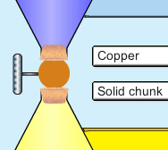
The Conduction and Convection Gizmo™ shows two flasks of colored water, one blue and one yellow. Select Copper and Solid chunk from the dropdown lists. (This means the two flasks are separated by a solid piece of copper, and the two liquids cannot touch each other.)

- Use the sliders to make one flask hotter than the other. Click Play (). What happens? __________________
_____________________________________________

- Select the Data tab and look at the graph. What do the blue curve and the yellow curve represent?

  - The blue curve represents ______________________________________________

  - The yellow curve represents ____________________________________________

- What is the final temperature of the top flask? ____________ Bottom flask? _______

Activity A:  Conduction | Get the Gizmo ready:  - Click Reset ().  - Set the Initial temperature of the top flask to 95°C and the bottom flask to 5°C. | 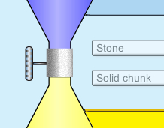

Question: Conduction is the transfer of heat from one object to another by direct contact. Which materials conduct heat most easily?

- Observe: Run the Gizmo twice – once with a Solid chunk of Copper separating the liquids, and once with a Solid chunk of Stone. Watch how quickly the temperatures of the liquids change in both cases. (Note: This solid chunk keeps the liquids from mixing.)

- Form hypothesis: A conductor allows heat to flow easily, while an insulator resists heat flow. In general, what kinds of materials do you think are good conductors?

_________________________________________________________________________

- Predict: Of the six substances in the Gizmo, which ones will allow the fastest temperature change in the two flasks? ____________________________________________________

- Experiment: Experiment with all six Solid chunks. For each, click Fast forward () and then, after about 500 seconds, Pause (). Record the temperature of each flask.

Connection | Initial temp. (top flask) | Initial temp. (bottom flask) | 500 sec. temp. (top flask) | 500 sec. temp. (bottom flask)
Solid copper | 95°C | 5°C
Solid gold | 95°C | 5°C
Solid lead | 95°C | 5°C
Solid stone | 95°C | 5°C
Solid glass | 95°C | 5°C
Solid rubber | 95°C | 5°C

- Analyze: What substances conducted heat the best? _______________________________

How do you know? _________________________________________________________

- Draw conclusions: What do the best conductors have in common? ____________________
_________________________________________________________________________
Activity B:  Convection | Get the Gizmo ready:  - Click Reset.  - Select Glass and Hollow pipe in the dropdowns. | 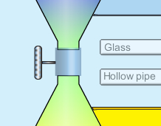

Question: Convection is the transfer of heat by the movement of matter. In what situations does convection work best?

- Observe: The Hollow pipe allows the water in each flask to move around and mix. Try several experiments with different temperatures in the top and bottom flasks.

  - Describe what you see: ________________________________________________

___________________________________________________________________

  - How does the color show when convection (movement of hot water) is taking place? ___________________________________________________________________

- Form hypothesis: Why do you think the water mixes quickly in some cases, while other times the water mixes slowly? _________________________________________________
_________________________________________________________________________

- Experiment: Predict the results of each experiment by writing “fast” or “slow” in the predictions column. Test your predictions on the Gizmo, and record the actual results.

Initial temperature (top flask) | Initial temperature (bottom flask) | Mixing speed (predictions) | Mixing speed (actual results)
95°C | 5°C
5°C | 95°C

- Analyze: How do the positions of the hot and cold water affect the speed of convection?

_________________________________________________________________________

_________________________________________________________________________

- Draw conclusions: Does hot water tend to rise or sink? Explain. ______________________

_________________________________________________________________________

Activity C:  Conduction vs. convection | Get the Gizmo ready:  - Set the Initial temperatures of the top flask to 30°C and the bottom flask to 70°C.  - Select Gold from the dropdown list. | 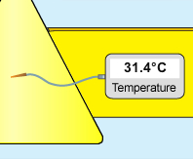

Question: Which works more quickly, conduction or convection?

- Observe: Experiment with a Hollow pipe of Gold and a Solid chunk of Gold separating the flasks. Compare how quickly heat is exchanged.

- Form hypothesis: Heat can be transferred by conduction or convection.
  - Which process do you think is quicker? ____________________________________
  - Why do you think this is so? ____________________________________________
___________________________________________________________________

- Experiment: For each of the situations below, record the temperatures after 100 seconds.

Connection | Initial temp. (top flask) | Initial temp. (bottom flask) | 100 sec. temp. (top flask) | 100 sec. temp. (bottom flask)
Solid gold | 30°C | 70°C
Hollow gold | 30°C | 70°C
Solid gold | 70°C | 30°C
Hollow gold | 70°C | 30°C

- Draw conclusions: Does convection always work more quickly than conduction? Explain why or why not. ____________________________________________________________
_________________________________________________________________________

- Extend your thinking: You may have noticed that there was a big difference in the results of the two hollow pipe experiments, but very little difference in the solid chunk experiments.

Why do you think this was the case? ___________________________________________

_________________________________________________________________________

_________________________________________________________________________

Lesson 3 Alternatives

Activity Preference A

Read online tutorial at http://www.fordhamprep.org/gcurran/sho/sho/lessons/lesson210.htm

*You may wish to use the online calculator at http://pbskids.org/cyberchase/games/calculator/index.html to try the guided practice and independent practice problems on the lesson 3 handout.

Activity Preference B

Watch online you tube tutorial at

http://www.youtube.com/watch?v=dA3ePiwSyGY

http://www.youtube.com/watch?v=XwCLvJdVrIs

*You may wish to use the online calculator at http://pbskids.org/cyberchase/games/calculator/index.html
to try the guided practice and independent practice problems on the lesson 3 handout.

Activity Preference C

Watch the close captioned, narrated power point guided examples entitled, “Calculating Thermal Energy.”

Then complete the independent practice problems on the lesson 3 handout.

