Technology Integration Reflective Paper
When I created the proposal for my technology integration project, part of the assignment was to create a rubric detailing ten criteria on which I would score my project. I want to address those ten criteria and self assess after implementation of this mini-Skype unit called, “Cells: The Good, the Bad, and The Ugly,” in my eighth grade classroom.
The first criteria included the design of a mini-unit. I feel as though I deserve ten points for this area, as my carefully designed three unit lesson is posted on my website. The three lessons include, “The importance of Cell Division, Built in Controls for Mitosis, and Out of Control Mitosis: The actual Skype Lesson.” These lesson plans are available on my website: www.kbailey.webnode.com for review. The first two lessons included two power points which are also available for viewing on the website, as well as the resource sites students used in each lesson. Each lesson included a rubric/scoring guide stating specifically how students would be graded, and the first two lessons include actual scanned work from students as stated in the initial proposal.
The second criteria included effectiveness of lesson objectives. I feel as though this area deserves ten points. Students reached each lesson’s goal with an above average to excellent performance level. We began each lesson with a review, and students knew content when reviewing orally, and student work that appears on the website shows students have reached objectives.
In terms of interactivity of Skype, I also feel that this area deserves a nine or ten. All four students in this lesson asked questions throughout the Skype conversation at least three times each. I would have liked for students to have been completely relaxed so that they would have asked spontaneous conversations or have fed off a comment or statement the speaker discussed. Neither students nor I had ever Skyped in the classroom before. Students were not familiar with the speaker, and were very conscious of being recorded, as a result they did ask questions, but they did not go much further than that.
The fourth criteria included scoring a real world connection. Without doubt, this lesson included the aspect of making a real world connection. Students were able to hear real life discourse about out of control mitosis, as well as ask questions of a real life nurse practitioner. I think this criterion was indeed met, and deserves ten points.
The fifth criteria were Skype audio. I feel as though this area deserves eight points. The Skype audio was, without doubt, good throughout the entire conversation. There was only one point in which we as the receiving end had to repeat what we had said. The speaker himself always understood us, as his responses indicated so. At times the audio would hold out words for an extended period of time. Of course, there was a delay in the voice versus the mouth of the speaker. The speaker had to set-up his connections near a local Hardees in his vehicle, as he had difficulty connecting to his work place Internet connection. He actually Skyped from Leslie County while our students were in Knott county, and Leslie County has difficulty with cell signal and Internet signal as it is. So given that obstacle, the audio was better than I expected, and good for conversation. It could have been improved, but it was enough to reach lesson objectives. We had one break in conversation where both audio and video were disconnected. We were only disconnected for about two minutes, and then were able to get back on track. I would give this area at least eight points, just because volume was never a problem. The real issue was words being held out a big longer, and that was not a major issue.
The sixth criteria included Skype video. The video connection was great. There was very little blur, and both students and speaker were well able to see each other. You can view the evidence of this criterion for yourself by viewing the two sample Skype clips from the lesson, which are on my website. Keep in mind that the entire lesson is not on the website. The sample clips did not include me stating the lesson objective and scoring guide to students. I simply included the actual Skype portion of the lesson using a free software found online entitled, “Evaer.” Evaer allows you to record your Skype conversations. I then used these windows media files and uploaded them to YouTube so that they could be easily accessed within my website for your viewing pleasure. As the audio, the video of course did have a short break for about two minutes, and then we were able to get back on track.
The seventh criteria included student formulated questions. This area deserves at least a 9. I had two student who formulated five questions each. The third and fourth student formulated four questions. These can be viewed by looking at students scanned sample work under lesson one on my website.
The eighth criteria involved student reflections. I specifically stated that I would like to see student reflections reach a highly effective mark on experience with the real world speaker. I did not want to sway or get biased results on this portion of the assignment, so I created a survey through www.polldaddy.com that included 5 questions, which you can view below. Students were able to take the survey anonymously, which really helped me to see how students truly felt about the lesson itself. Please see the results on the survey below. I did not stress spelling and grammar to students when completing the survey, so I apologize in advance for the spelling and grammar errors as seen in their responses to question 2. Ultimately, I feel the results show that this area deserves at least an eight or even a nine.
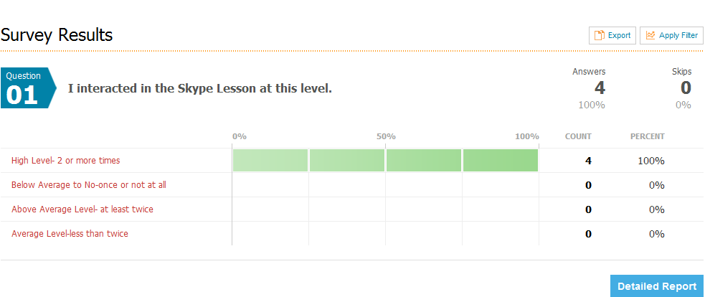
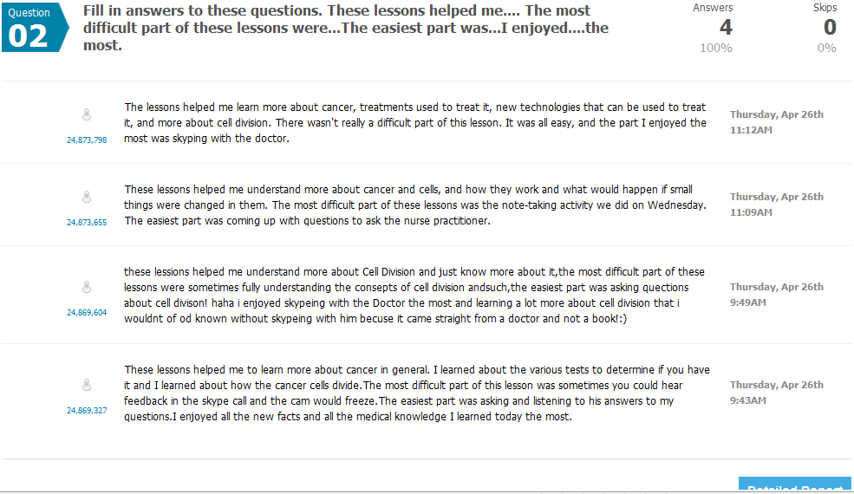

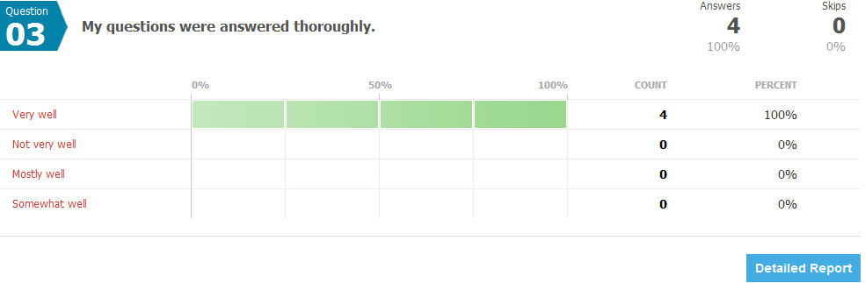

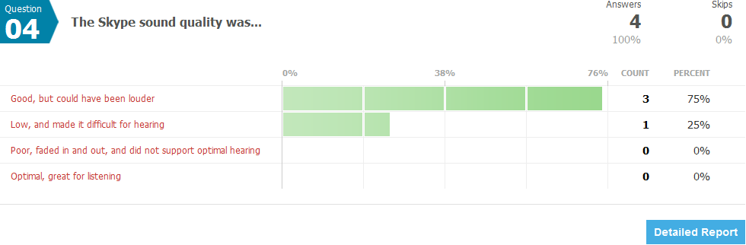

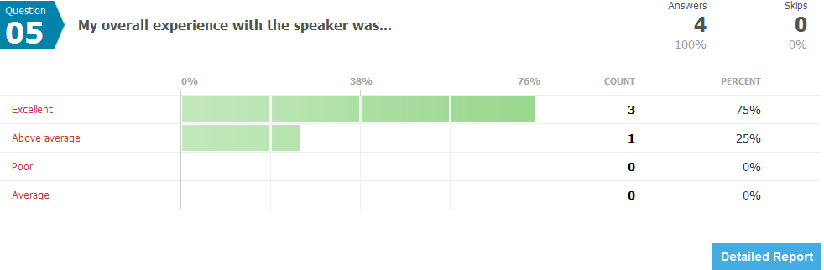
The ninth criteria indicated that I would provide a video footage that shows the goals were reached within the lesson itself. While the video sample does not show the lesson objectives and the fact that I went over the rubric, it does show the interaction within the Skype lesson between the Speaker, the students, and myself. I feel as though it’s very authentic as it should be. I think this criterion deserves a ten.
The tenth criteria included the utilization of Bloom’s taxonomy. When looking back at my lessons the key Bloom’s verbs used were: explain, formulate, understand, and discuss. When I compare this to Bloom’s Taxonomy these verbs fall under the second level: Understanding, and the highest level: Creating. As a result, I feel as though this area deserves at least 7 or 8 points
Overall, this project was a success. I had no idea how to Skype, and had no idea it would be as simple as it was. I explored the Skype Education portion of the website only to find that several educators are using this tool in innovative ways. I’m looking forward to exploring this tool further and integrating it and sharing it with my co-workers. When looking back at my steps to complete this project, all steps were taken, and all criterions were met at an above average to excellent level. I hope you enjoyed reviewing the project itself. I enjoyed trying something new, and am looking forward to progressing as an educator by continuing to try things I’ve never done before. In essence, this is the only way to learn!

**Please note that paper is a bit longer due to the fact that I wanted to insert the actual survey created within the paper itself.

